**Variables:**

A variable is a container which holds the value.

A variable is assigned with a data type.

Types of Variables

There are three types of variables in java

* local variable
* instance variable
* static variable

local variable: A variable declared inside the body of the method is called local variable.

Instance variable: A variable declared inside the class but outside the body of the method, is called an instance variable.

Static variable: A variable declared inside the class but outside the body of the method, is called an instance variable.

**Public Static void main(String[] args)**

This is the Java’s main()method is the starting point from where the JVMstarts the execution of a Java program.

JVM will not execute the code if the program is missing the main method.

It is one of the most important method for writing the program.

The Java compiler or JVM looks for the main method when it starts executing a Java program.

Without the main method the compiler will not start to compile the code.

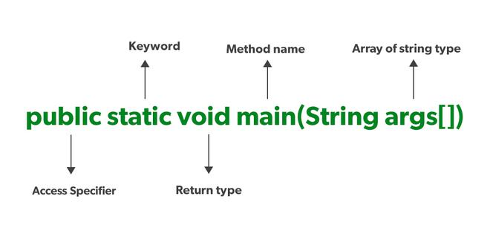

**Public:**

Public is an access specifier it defines the accessiblity of the variable and method

The variables and methods are define using this public keyword.

It is like a main method we can access it from anywhere in the program.

Without defining the main method we will get the error.

**Static:**

The static keyword in java is used for memory management.

We can use static with variables and methods.

The static keyword belongs to the class.

static methods can be called without using objects.

**Void:**

It is a keywordand is used to specify that a method doesn’t return anything.

As the *main()* method doesn’t return anything its return type is void.

If the main method is not void then we will get the error it is empty data.

**Main:**

It is the name of the Java main method.

It is the starting point of the Java program.

It’s not a keyword.

**String[] args:**

String[] args it is a parameter that accepts String type arguments.

It allows us to pass arguments through terminal and it stores these arguments in an array of strings.

We can say that String[] args is a command line argument.

**System.out.println():**

It is used to print the text or values to the terminal.

The println() is used to display the output to the terminal.

The System class that provides standard mechanisms to obtain input, write output and log error messages.

The PrintStream named *out*which can be configured to write text to either the console window or to log files.

The print method which is passed a text String to print out.

**Shortcuts for quick navigation in Eclipse**

1. Ctrl + 3: Quick access to any menu item or feature in Eclipse  
2. Ctrl + Shift + T: Open a type quickly  
3. Open a resource (e.g., file, image): Ctrl + Shift + R.  
4. Ctrl + O: Quickly navigate to a method in the current class  
5. Ctrl + 1: Shows available code actions and quick fixes  
6. Quickly navigate to the superclass or implemented interface of the current type with Ctrl + T.  
7. Ctrl + Shift + L: Used for “Show Key assist,” previously used for Quicksearch  
8. Ctrl + Q: Quick navigation to the last edit location (last edited line).

**Eclipse shortcuts for debugging**

1. F5 (Step into): This allows you to enter debug mode.  
2. F6 (Step over): This assists in moving to the next line without leaving debug mode.  
3. F7 (Step out): This allows you to step out/return to the current method/caller in debug mode.

**Manage Files and Projects**

**Ctrl+N=** Create new project using the Wizard

**Ctrl+Alt+N**= Create new project, file, class, etc.

**Alt+F**= Open project, file, etc.

**Ctrl+Shift+R** =Open Resource (file, folder or project)

**Alt+Enter** =Show and access file properties

**Ctrl+S** =Save current file

**Ctrl+Shift+S** Save all files

**Ctrl+W=** Close current file

**Ctrl+Shift+W=** Close all files

**Select Text**

**Shift+Arrow Right/ Arrow Left**= Expand selection by one character to the left / to the right

**Ctrl+Shift+Arrow Right/Arrow Left**= Expand selection to next / previous word **Shift+Arrow Down/ Arrow Up** =Expand selection by one line down / one line **up Shift+End/Home**= Expand selection to end / to beginning of line

**Ctrl+A=** Select all

**Alt+Shift+Arrow Up** =Expand selection to current element

**Alt+Shift+Arrow Left/Arrow Right**= Expand selection to n

**Alt+Shift+Arrow Down** =Reduce previously expanded selection by one step.

**Methods in java**

A method in Java is a block of code that performs specific actions .

if you have written instructions to draw a circle in the method it will do that task.

You can insert values or parameters into methods and they will only be executed when called

It allows code reusability means define once and use multiple times

* You can break a complex program into smaller chunks of code
* It increases code readability

**Types of Methods in Java**

There are two types of methods in Java:

**1. Predefined Method**

In Java, predefined methods are the method that is already defined in the Java class libraries is known as predefined methods.

It is also known as the standard library method or built-in method.

We can directly use these methods just by calling them in the program at any point.

**2. User-defined Method**

The method written by the user or programmer is known as a user-defined method.

These methods are modified according to the requirement.

**Java Program to print different data types**

